ARROW FUNCTIONS

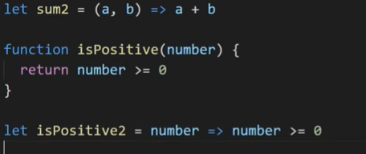

Let ar_name = (0,1,… parameters) =>{  
 //code

Return something

}

let ar_name = one_parameter => values to be returned

Our project can not run with just a few libraries. It is dependent on many packages otherwise called dependencies. Hence npm is used to manage all these dependencies. Like a package’s version number is taken care of in the package.json file.

* npm: It is a package manager that manages packages and does not stand for node package manager.
* npm allows you to install, update, and uninstall packages that your application needs.
* And npm does that using a package.json file. This file contains all the info regarding the dependencies.
* Package.json is the configuration file for npm.
* So, npm is a powerful tool that manages packages for your JavaScript applications, making it easier to handle dependencies, automate tasks, and ensure your project runs smoothly.
* Bundlers take all your application’s modules (JavaScript files, stylesheets, images) and combine them into fewer files. This reduces the number of HTTP requests needed when a browser loads a webpage, leading to faster load times.
* In my application I’ll be using a bundler called Parcel.

So there are 2 types of dependencies being installed in the application and they are :

• **Normal Dependencies** are essential for your application to run in production.

• **DevDependencies** are used during development for tasks like building, testing, and linting, and are not required in the production version of your app. And Parcel is a Dev dependency.

Command to install parcel:

npm install -D parcel : Here -D tells npm that parcel is needed as a devdependency.

tilde vs caret npm: ~ updates majors version of the existing package automatically and ^(caret) updtes the minor version automatically.

Always recommended to use caret over tilde.

Difference between package.json and package-lock.json:

The 1 file/module contains the approx. version details and the latter contains the exact version details of dependencies.

The package-lock.json contains an integrity object which is sha512 hash that basically verifies if the current version on the local developer machine is the same as the one sent to production.

Package JSON contains the details of the dependencies while the node manager contains the actual code of these dependencies.

Transitive dependency:

Our application needs parcel as a dependency but parcel on its own requires other dependencies like barbel. And that my dear is transitive dependency.

So npm is for installing the dependencies (generally) and npx is for executing the dependencies using npm without having to install them globally.

So previously we configured our project to use React using CDN links, but now we can install react as a normal dependency using the commands npm install react and npm install react-dom.

Parcel is a very powerful tool that does so many things like:

* Bundling for production
* Optimization
* Provides a local server to view the website
* Tree shaking- removing unnecessary functions from the code
* HMR(Hot Module Replacement) meaning it does live reloading without having to manually refresh the entire page.
* Image Optimixation.

Browser’s list(used for making our website compatible with older version’s of web browsers):